PD Session: Poster Draft Evaluation Session
Lead Presenter: Anant Kukreti, Director for Engineering Outreach for the College of Engineering and Applied Science, University of Cincinnati
Co-Presenters: Debbie Liberi, District Coordinator for the CEEMS grant and Coordinator for the RET Program, University of Cincinnati
Amy Jameson, RET Resource Teacher, Dater High School
Date: July 12, 2017
Time: 9am-11am
Venue: University of Cincinnati, Swift Hall, Room 516
Prepared by:
Kimberly Lykens, Stebbins High School, Dayton, Ohio
RET Participant for Project #1: “Synthesis and Characterization on Different Forms of Cu Nanoparticles to Mitigate Cu Leaching to Water Bodies”

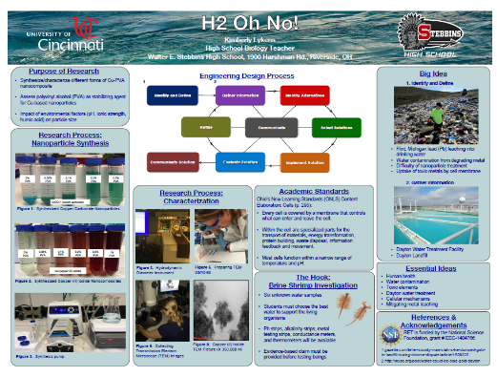
This poster evaluation session was led by Dr. Kukreti, the Director for Engineering Outreach for the College of Engineering and Applied Science and Professor in the Department of Biomedical, Chemical and Environmental Engineering. Dr. Kukreti teaches structural mechanics, with research in steel structures, seismic analysis and design, and engineering education. The co-presenters of this session were Debbie Liberi, the District Coordinator for the CEEMS grant at UC and as Coordinator for the RET Program, and Amy Jameson, a physics teacher at Dater High School and designated RET Resource Teacher. All three presenters worked together during this session to provide valuable feedback to RET participants on the atheists, professionalism, and effectiveness of their RET poster draft. This professional development session was held July 12, 2017 from 9am-11am at the University of Cincinnati in Swift Hall (room 516).
Figure 1. An Example of a RET Poster Presented by RET Participant, Kim

The session began by Debbie asking the RET participants for volunteers to go first. Each RET participant was instructed to pull up their poster draft on the classroom projector and the presenters critiqued the posters based on appearance and content. Kat, a RET participant, was the first to present her poster on air quality. The feedback Kat received from Dr. Kukreti, Debbie, and Amy included condensing some of the sections to bullet points in order to make the poster less “wordy.” Furthermore, it was suggested that the essential questions not be presented on the poster because these posters are going to be displayed in classrooms. Instead, Debbie suggested bullet points of the main topics that will be discussed within the essential questions instead of citing the essential questions themselves.
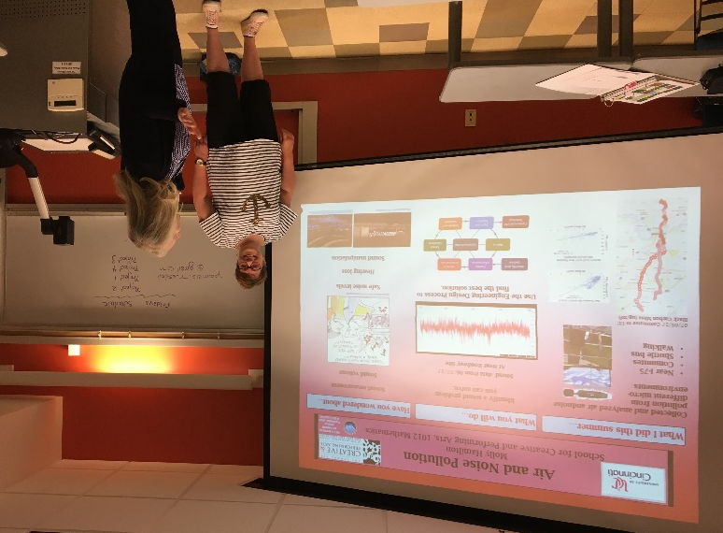
Figure 2. RET Participant, Molly, Receiving Poster Feedback from Debbie Liberi

John, another RET participant, presented second with his poster about computational thinking. John also received feedback on changing paragraphs to bullet points in order to make the poster more aesthetically pleasing. Kim was the third RET participant to present her poster (Figure 1). Positive feedback was received from Dr. Kukreti, Debbie, and Amy; however, it was suggested that the title be shortened and the title “Essential Question” be changed to “Essential Topics.” The next presenter, Molly, also received a lot of positive feedback about her poster (Figure 2). It was suggested that Molly enlarge her center picture because the words could not be seen from the back of the room.

The last RET participants to present included Michael, Tiara, Todd, and Ryan. The evaluators really liked Tiara’s poster because it looked as if it was made for her students. The color, great use of pictures, and minimal amount of words was effective for the poster purpose. It was suggested that Tiara use a bulleted list to describe her research and that she add more pictures of her working in the lab. Michael’s poster also received good feedback because he used a great color scheme that fit well with his research. Todd and Ryan both received feedback that included shortening paragraphs to make more concise bullet points. The RET poster evaluation session ended by Debbie, Amy, and Dr. Kukreti congratulating all RET participants on the great progress they have made with the posters and reminded everyone to remove the red line from the poster that was used for a frame of reference.

